Terraform Task-2

Task Description:

Create 2 EC2 instances on 2 different regions and install nginx using terraform script.

Steps:

Used the attached main.tf file & created 2 instances with nginx

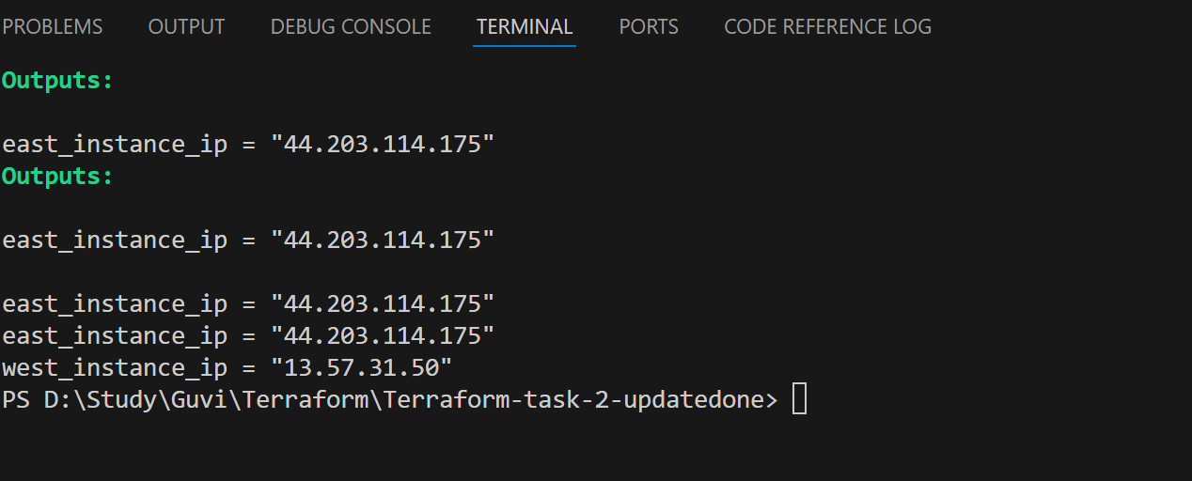
Accessed public ip in browser, replaced default nginx html file with static content

